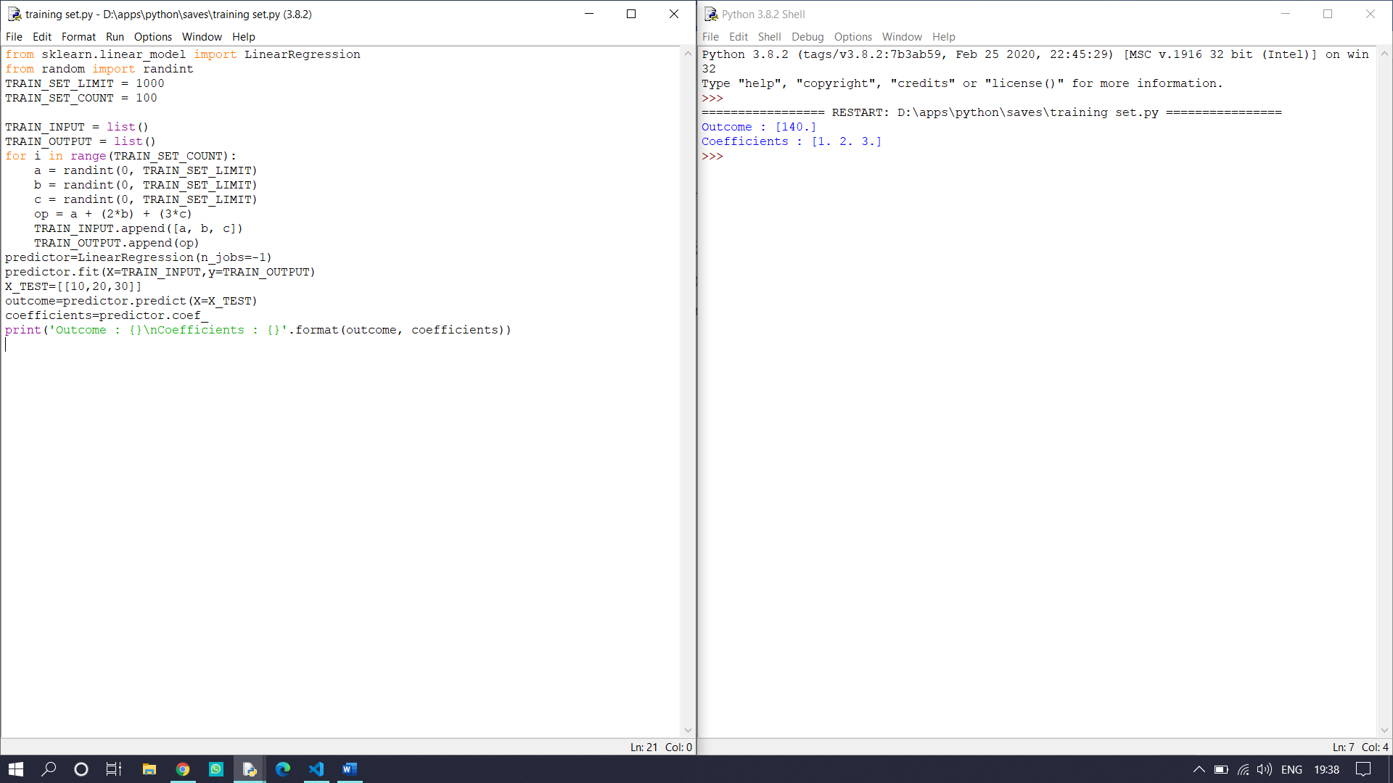
Input:10,20,30->output:140, coefficients:1. 2. 3.

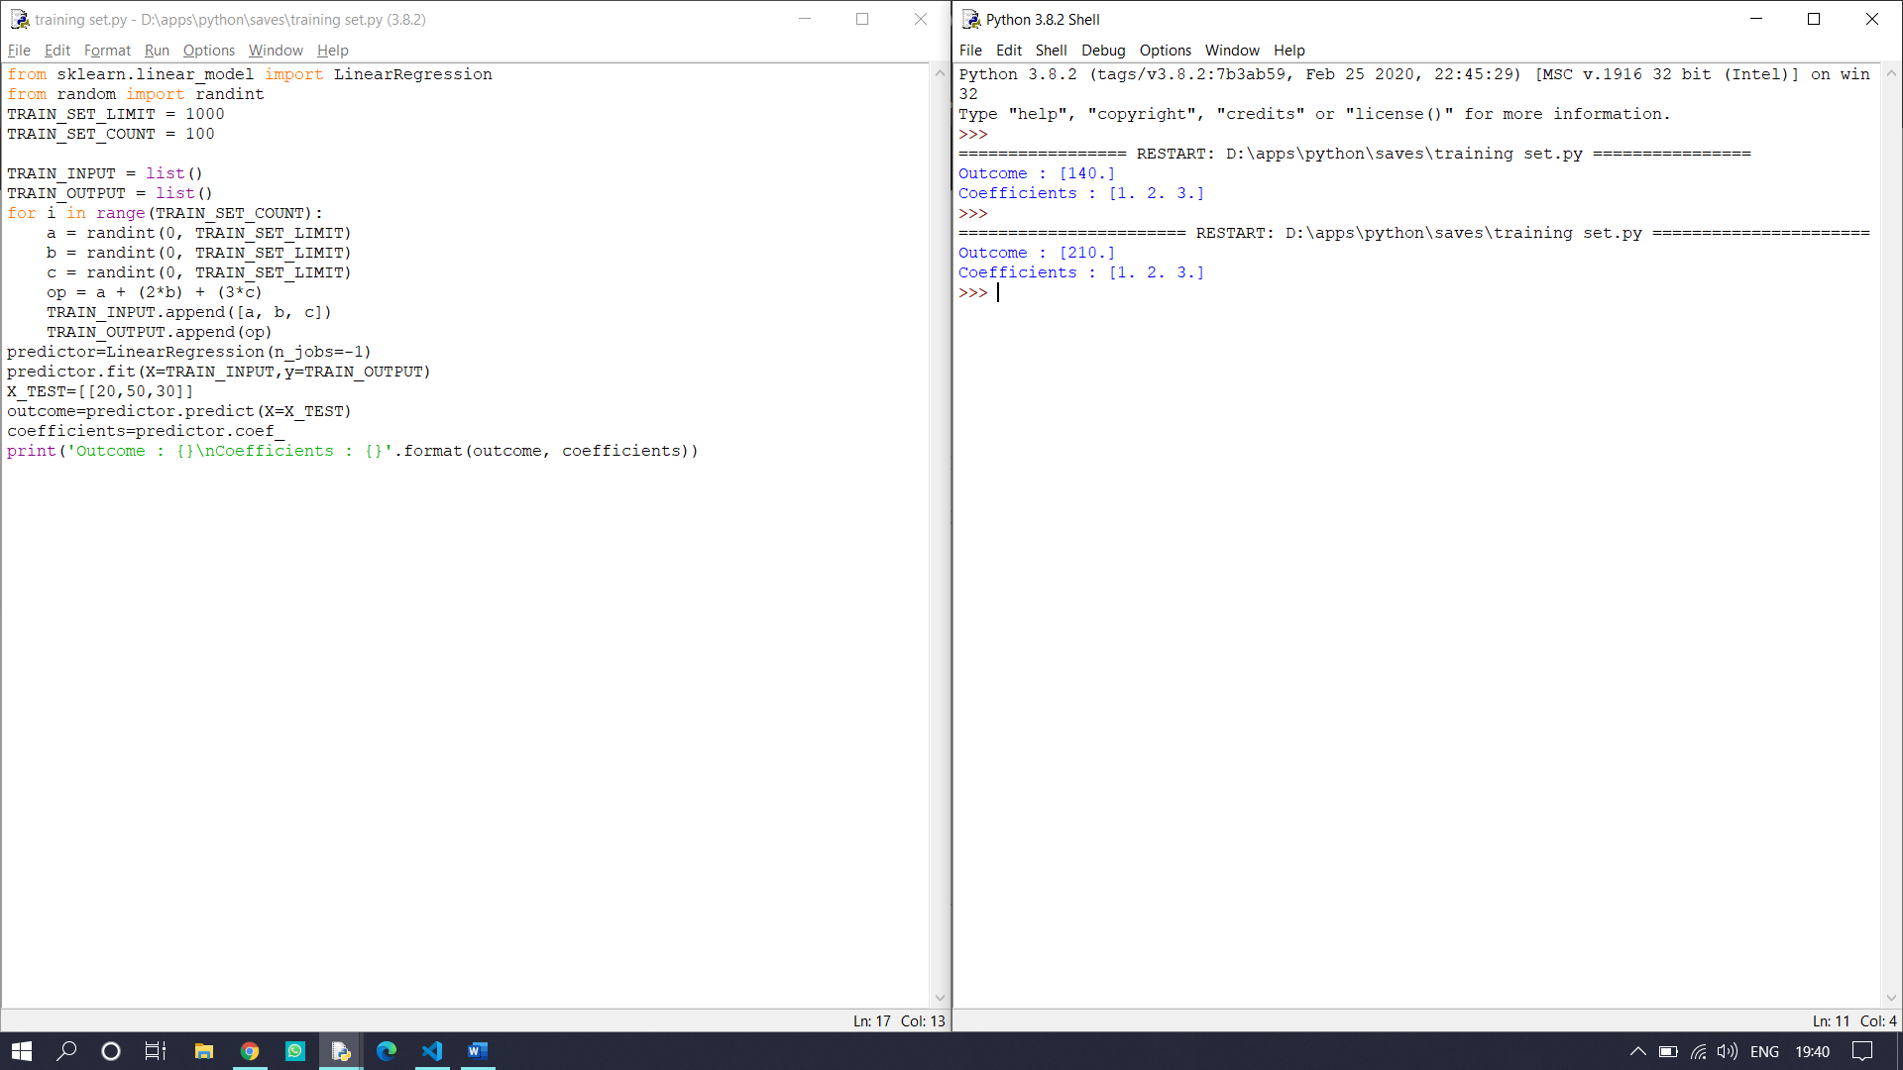
Input:20,50,30->output:210, coefficients:1. 2. 3.

